**Faculty Profile Template**

1. **Basic Information**

* **Name**: Prapti pandey
* **Designation**: Assistant Professor
* **Department/School**: Computer Science and Engineering
* **Institution Name**: SSIPMT, Raipur
* **Email ID**: prapti.pandey@ssipmt.com
* **Contact Number**: 7225990440
* **Photograph**:

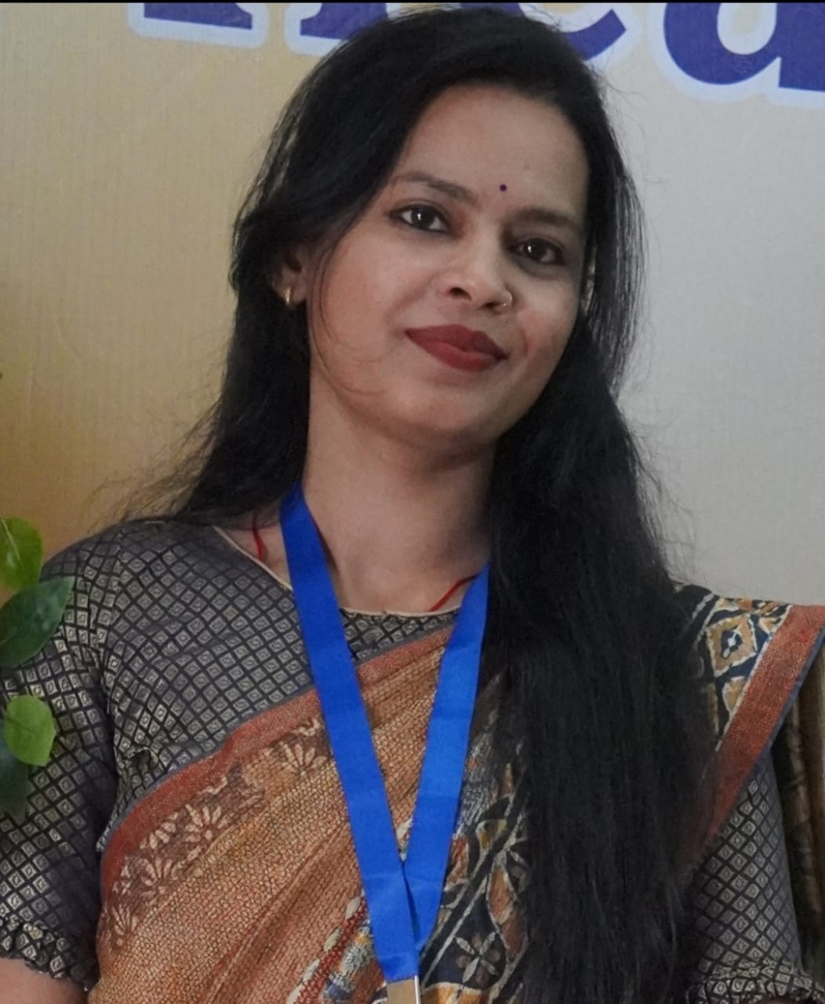

1. **Educational Qualifications**

|  |  |  |  |
| --- | --- | --- | --- |
| **Degree** | **Specialization** | **Institution** | **Year of Completion** |
| UG | CSE | JKIE | 2013 |
| PG | CSE | TIT | 2017 |
| Ph.D. | CSE | CVRU | Pursuing |
| Others | *(if applicable)* |  |  |

1. **Teaching & Research Experience**

* **Total Teaching Experience**: 1 year
* **Industry Experience**: *NIL*
* **Research Experience**: NIL

1. **Courses Taught**

* FOC,PPS, C++, HTML

1. **Research Interests / Specialization**

* Machine learning, Image processing, Artificial intelligence, IoT

1. **Publications (Last 5 Years)**

* Journals (APA/IEEE format) -1
* Conference Proceedings-4
* Book Chapters / Books Authored-0

1. **Research Guidance**

|  |  |  |
| --- | --- | --- |
| **Level** | **Awarded** | **Ongoing** |
| Ph.D. | NIL | NIL |
| PG | NIL | NIL |

1. **Awards & Recognitions**

**NIL**

1. **Administrative Roles**

* IA

1. **Professional Memberships**

* NIL

1. **Web Presence**

* Google Scholar